Friday 18th February 2022
Year 5: have a great day, stay safe and enjoy your half term, I look forward to seeing you all next term. If you could write or type up any of your answers then that’ll be great, you don’t have to upload anything, although if you know your team’s details you can. If not please do not worry.
English: Read through the following transcript. Read once to get used to the words and then a second time read out loud thinking about how your character seems.

Transcript – Interview 13th June 1954
Interviewees – Sheila Mowday, Sarah Mowday (her daughter), Alan Mowday (her son), Commander Jones (Royal Navy), Professor Edith Ayre (Expert).
Interviewer: | Thank you for agreeing to meet me. I wanted to talk with you while the events of yesterday were still fresh in your mind. Would you start by telling me what kind of day it was?
Sheila Mowday: | Well we thought it was going to be a really normal day. We went along to the park because we wanted to see the display. We really had no idea what was going to happen.
Interviewer: | What was the weather like?
Sarah Mowday | It was pretty grey. I remember thinking it was going to rain and that’s why we took our coats and our umbrellas with this
Interviewer: | And when did you first notice that this wasn’t usual rain?
Alan Mowday | It was when we were under the tree. We went there to shelter because the rain had started to get really heavy. And it was me that noticed it first. I thought ‘that doesn’t feel like rain’. It was heavy. More like hail. So I held out my hand and there was a frog.
 | How would you describe the frogs?
Sarah Mowday | They were small. Really tiny. Like little droplets. You had to look closely to see what they were. But when you looked, you could see their legs and faces and everything.
Interviewer | How long did the shower last?
Sheila Mowday | Oh. Not for long at all. I’d say that it lasted for about two or three minutes. But we were covered in frogs by the end of it and we could barely walk away.
Interviewer | And what were other people doing in the park?
Alan Mowday | Well. That’s the funny thing. No-one else seemed to notice. They had their umbrellas up and they looked wet too, but they didn’t seem to notice the frogs.
Sheila Mowday | We tried asking people. But they looked at us a bit strangely. They didn’t really want to talk. That’s why I contacted the paper. I thought you should know.
Interviewer | We have Colonel Jones here who was part of the team organising the event. Colonel Jones, what do you make of this report?
Commander Jones | Well I have to say, that none of my team noticed anything like this. It really is quite a thing! And this is the first I’ve heard of it. It was rainy, yes. And it felt like very heavy rain. But, frogs? I really think we would have noticed if there had been frogs. I find the whole thing very strange.
Sheila Mowday | I’m not making it up!
Commander Jones | I’m sure you’re not madam. I’m just surprised that no-one else noticed. I wonder perhaps if someone was playing some sort of joke on you.
Professor Edith Ayre | Perhaps, I might interrupt at this point?
Interviewer | Of course. We are glad to have your expertise here.
Professor Edith Ayre | I just want to remind everyone that we know that these sort of events happen. They were reported in the first century in Rome and in 1794 French Soldiers saw toads falling from the sky.
Commander Jones | But how could they possibly happen?
Professor Edith Ayre | Well, one thought is that it’s due to tornados. If they form over water, they could transport animals up and away over rather long distances. They would then fall to the ground in a shower.
Sheila Mowday | Well it sounds like something like that happened to us. I’ve got one of the frogs here as a matter of fact, if you would like to take a look.
2. Think about the characters. Try to find a phrase that they say that shows these things could be true.
- Commander Jones was dismissive
- Professor Ayre was a bit frustrated
- Sheila Mowday felt she was being doubted
3. Write a short summary of the interview as though you are the interviewer, using reported speech. Summarise roughly what each person said.

Geography Rivers Quiz. (answers at the end)
Also available to do following this link:
KS2 Rivers | What are the Features of a Watercourse (educationquizzes.com)
- What name is given to the bottom of the river?
Delta
Bank
Bed
Channel
- What is deposition?
River deposits rocks and soils as it flows
River carries rocks and soils as it flows
River removes rocks and soils as it flows
River dries up
- Where a river deposits sediment faster than the sea can remove it what feature forms?
Valley
Delta
Mountain
Channel
- What are the sides of the river called?
Delta
Banks
Bed
Channel

- When a river carries rocks and soils it is known as what?
Deposition
Erosion
Transportation
Flooding
- The wide part of the river near the sea is called what?
Tributary
Valley
Channel
Estuary
- What is erosion?
River deposits rocks and soils as it flows
River carries rocks and soils as it flows
River removes rocks and soils as it flows
River dries up
- In which part of the river does water flow the fastest?
Upper course
Middle course
Lower course
Estuary
- Where is the source of a river?
Near the sea
Mud flats
Lakes
High ground
- What are smaller rivers flowing into another river called?
Tribulations
Estuaries
Deltas
Tributaries
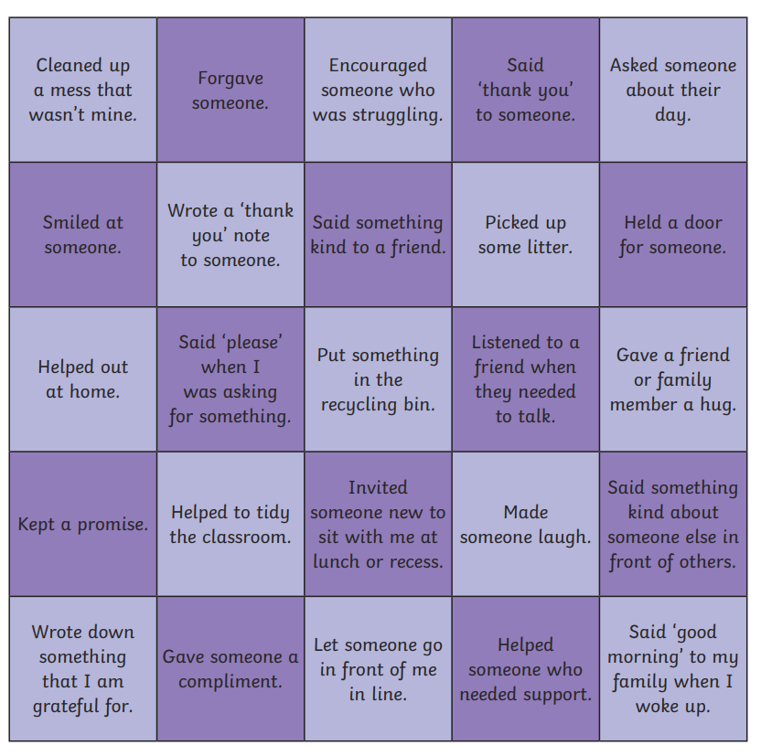
PSHE/Assembly: Yesterday was Random acts of kindness day. Could you write down 5-10 targets of ways you think you could show a random act of kindness this half term? Or play a bingo game: How many do you complete? Cross them off if you have done them this week.

Quiz answers:
- Bed
- River deposits rocks and soils as it flows
- Delta
- Banks
- Transportation
- Estuary
- River removes rocks and soils as it flows
- Upper course
- High ground
- Tributary

