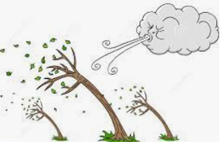
Class 1- Friday 18th February 2022
We will be posting on Dojo too, so if you want to send any work over we’d love to see it! If you have not connected then click the link and join us! https://www.classdojo.com/invite/?c=CQHTXJK

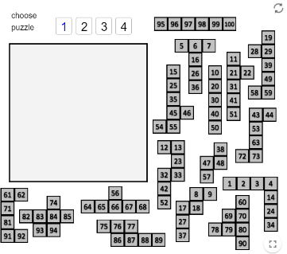
Maths: These are great activities you can have a go at one or more at home!
We have been looking at numbers within 50.
Here are 2 great ideas for a maths session.
https://nrich.maths.org/5572
It’s a hundred square jigsaw that can be played on line! Be aware, it is very tricky!
https://nrich.maths.org/136
Noah's ark puzzle- rather appropriate with this rain!
This can be done using drawings, numbers, toys- it’s a great practical activity.

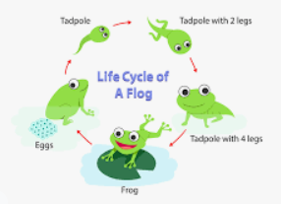
Science: Metamorphosis song. Listen to the song and see if you can learn the stages.
https://www.youtube.com/watch?v=DRTnN0TSDO4
There is a sheet if you want to do it. There are many ways of showing you know this information- you don’t have to write it- you could use plasticine and make the stages, draw them, act them out, talk them through- you choose! Upload your ideas if you want to on to class Dojo.
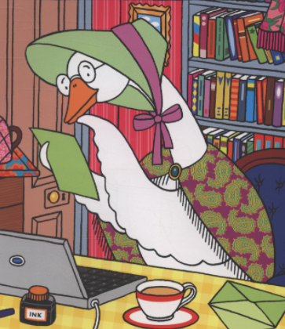
English: Have a look at the letter that we found at school after you all had left on Thursday! Can you have a go at writing the reply to her- she sounds like she needs some good advice from you! Remember to try to use all your phonics- we’ve added the sheet to help you. Don’t forget capital letters, full stops and question marks- remember to start with Dear Mother Goose, and end with love … We think you could write two to four sentences! Put it on Dojo if you want!
Mrs Betts and Mrs Rowcliffe

